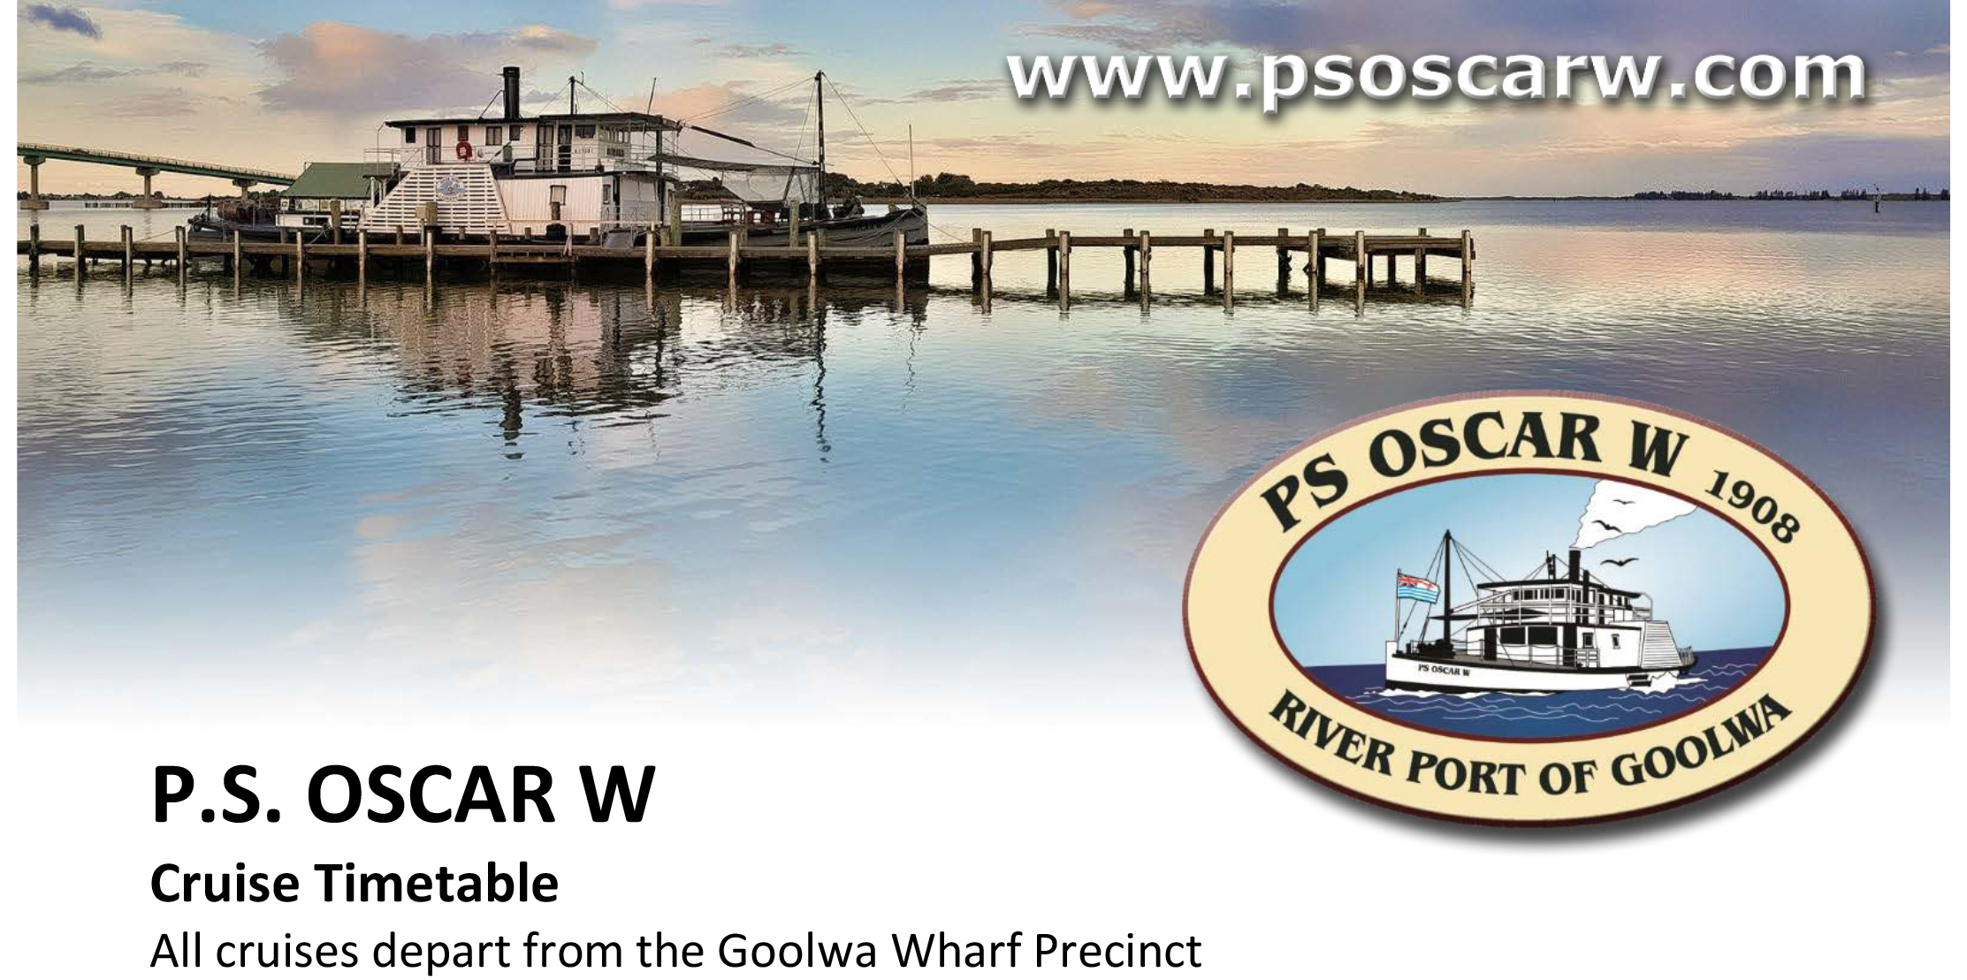

(Current from the 15.3.25 - Subject to change without notice)

Day | Date | Cruise
Saturday | 15th March 2025 | Lunch Cruise 10am – 3.30pm
Sunday | 16th March 2025 | 1 hour cruises 11am, 1pm & 2.30pm
Saturday | 5th April 2025 | Twilight Cruise 5pm – 7pm
Sunday | 6th April 2025 | 1 hour cruises 11am, 1pm & 2.30pm
Sunday | 20th April 2025 | Easter 1 hr cruises 11am, 1pm & 2.30pm
Friday | 25th April 2025 | Twilight Cruise 4pm – 6pm WBF
Saturday | 26th April 2025 | 1 hour cruise, 10.30am and 4pm WBF
Saturday | 26th April 2025 | Twilight Fireworks Cruise 7pm – 9pm WBF
Sunday | 27th April 2025 | 1 hour cruises, 11am and 1pm WBF  1 hour cruise 3pm Grand Parade Cruise
Saturday | 3rd May 2025 | Twilight Cruise 3.30pm to 5.30pm
Sunday | 4th May 2025 | 1 hour cruises 11am,1pm & 2.30pm
Saturday | 17th May 2025 | Lunch Cruise 10am to 3.30pm
Saturday | 7th June 2025 | Twilight Cruise 3pm - 5pm
Sunday | 8th June 2025 | 1 hr cruises 11am, 1pm and 2.30pm

CRUISING TIMES | PRICE PER PERSON | CHECK DEPARTURE TIMES
Twilight Cruise | Adult | $45.00
2 hours – Time Depends on the time of year | Concession | $40.00
 | Children (5-15) | $20.00
 | Family (2A-2Ch) | $115.00
1 Hour Cruises | Adult | $30.00
 | Concession | $25.00
 | Children (5-15yrs) | $10.00
 | Family (2A + 2Ch) | $75.00
Lunch Cruise | Adult | $90.00
Depart 10:00am | Children (4–12 yrs) | $45.00
Return 3:30pm | Cruise includes 2 course lunch at Pier 28 Clayton Bay


