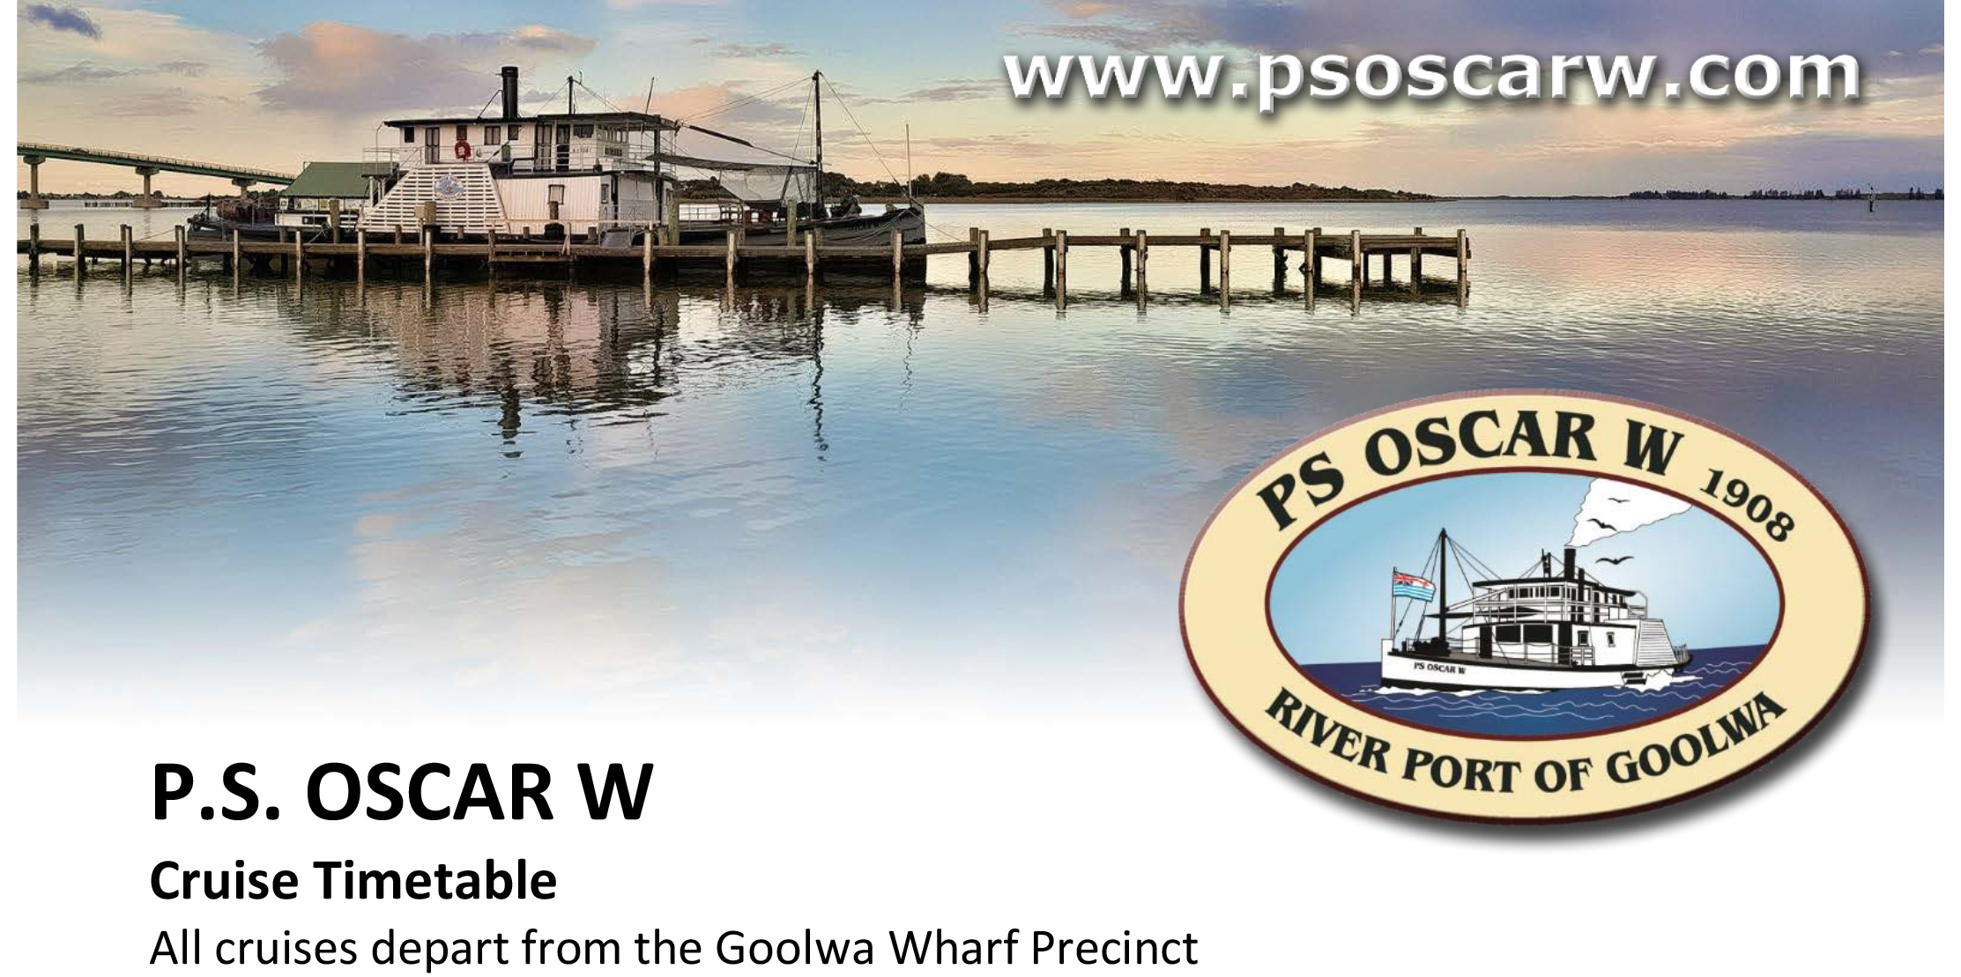

(Current from the 05.05.25 - Subject to change without notice)

Day | Date | Cruise
Saturday | 17th May 2025 | Lunch Cruise 10am to 3.30pm
Saturday | 7th June 2025 | Twilight Cruise 3pm - 5pm BYO
Sunday | 8th June 2025 | 1 hr cruises 11am, 1pm and 2.30pm
Saturday | 21st June 2025 | Lunch Cruise 10am to 3.30pm
Saturday | 5th July 2025 | Twilight Cruise 3.30pm to 5.30pm BYO
Sunday | 6th July 2025 | 1 hour cruises 11am, 1pm & 2.30pm
Thursday | 10th July 2025 | School Holiday 1 hr cruises 11am and 1pm
Saturday | 19th July 2025 | Lunch Cruise 10am to 3.30pm
Sunday | 3rd August 2025 | 1 hour cruises 11am, 1pm and 2.30pm
Saturday | 16th August,2025 | Lunch Cruise 10am to 3.30pm
Saturday | 6th September, 2025 | Twilight Cruise 4pm to 6pm BYO
Sunday | 7th September, 2025 | 1 hour cruises 11am, 1pm and 2.30pm
Saturday | 20th September, 2025 | Lunch Cruise 10am to 3.30pm
Sunday | 21st September, 2025 | 1 hour cruises 11am, 1pm and 2.30pm

CRUISING TIMES | PRICE PER PERSON | CHECK DEPARTURE TIMES
TWILIGHT CRUISE | Adult | $45.00
2 hours – Time Depends on the time of year | Concession | $40.00
 | Children (5-15) | $20.00
 | Family (2A-2Ch) | $115.00
1 HOUR CRUISES | Adult | $30.00
 | Concession | $25.00
 | Children (5-15yrs) | $10.00
 | Family (2A + 2Ch) | $75.00
LUNCH CRUISE | Adult | $90.00
Depart 10:00am | Children (4–12 yrs) | $45.00
Return 3:30pm | Cruise to Clayton Bay, bus to Finniss, 2 course lunch at Finniss General Store.
